**CHAPTER-1**

## 1. INTRODUCTION

Waste management and recycling are crucial aspects of environmental sustainability. With the increasing global population and urbanization, the amount of waste generated has skyrocketed, leading to pressing concerns about its disposal and environmental impact. Traditional waste sorting is often carried out manually, which is not only time-consuming but also prone to errors. Moreover, manual sorting is expensive and labour-intensive, creating a demand for automated waste management solutions that can streamline the process, reduce human error, and promote recycling on a larger scale.

The Automatic Waste Sorting Machine is an innovative solution designed to address these challenges. By integrating a range of sensors and microcontroller-based systems, the project automates the process of waste segregation into different bins. The system can detect metal, plastic, and glass objects, segregating them into individual waste bins based on their material type. This sorting mechanism not only makes the recycling process more efficient but also reduces the need for manual labour, making waste management systems more cost-effective and accurate.

The integration of sensors like inductive, capacitive, and ultrasonic into a machine controlled by Arduino microcontrollers opens up a new realm of possibilities for future applications. The machine is designed to sort three types of waste, with the potential to be adapted for additional types of materials. The aim of this project is to explore how automation can be leveraged to improve waste management, reduce waste contamination, and promote a more sustainable and eco-friendly approach to recycling.

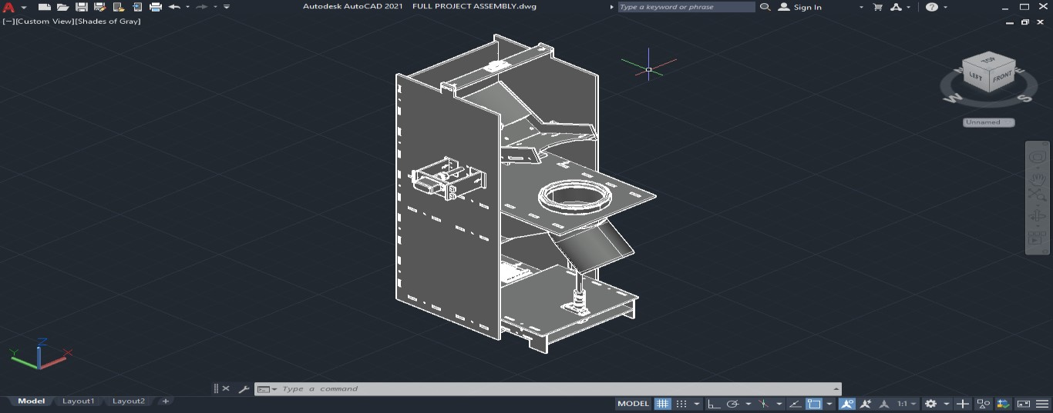

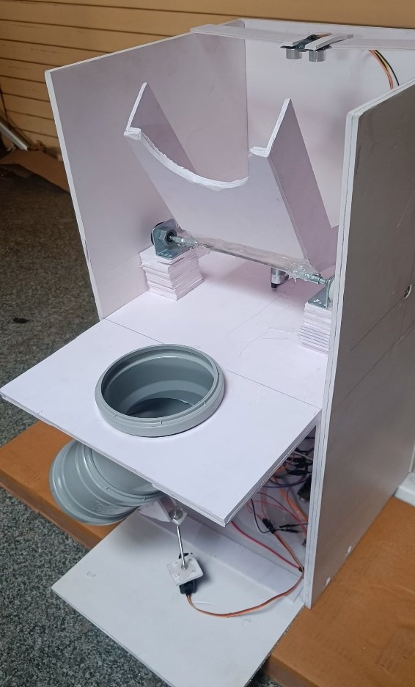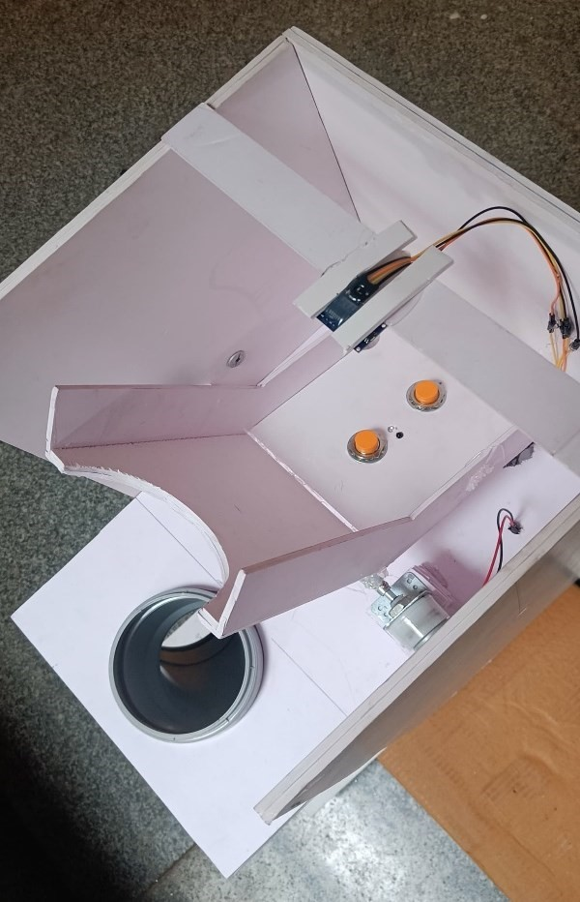

## 2. OBJECTIVES

The primary objective of this project is to develop a fully functional Automatic Waste Sorting Machine that is capable of sorting at least three different types of materials: plastic, metal, and glass. The specific goals of this project include:

Automating the Waste Sorting Process: By using sensors and microcontrollers, the goal is to automate the sorting of different materials into appropriate bins, eliminating the need for manual labour.

**Increasing Efficiency and Accuracy**: The system should efficiently sort materials based on their type, with minimal errors. By automating the sorting process, the project aims to reduce human error that typically arises in manual sorting systems.

**Designing a Scalable System:** The sorting machine is designed to handle waste from various environments, including households, offices, and industrial settings. The system must be scalable to accommodate different waste volumes and material types.

**Ensuring Sustainability**: The ultimate aim is to provide a solution that contributes to sustainable waste management practices. This includes improving the recycling rate and reducing waste contamination, which would enhance the quality of recycled materials.

**Adapting to Future Expansions:** While the machine is currently designed to sort three types of waste, the system architecture should be adaptable to sort additional materials in the future by integrating more sensors and improving detection algorithms.

The project will also focus on the design of a user-friendly interface for easy operation and maintenance, ensuring that the system can be easily integrated into existing waste management infrastructures.

## EXISTING SYSTEM

Automatic waste sorting is a complex task that has been a focus of research and development for several years. Current waste sorting systems rely on a combination of sensor technologies and mechanical actuators to automatically separate materials such as metals, plastics, and glass.

Below are a few examples of existing systems and their approaches:

**Automated Sorting Systems in Recycling Plants:**

Traditional recycling plants use machines equipped with a variety of sensors like infrared (IR) sensors, color sensors, and X-ray sensors to identify materials. For instance, AMP Robotics uses AI-driven robotic systems combined with machine vision to identify and sort recyclable materials from mixed waste streams. These systems rely on cameras to visually identify the type of material, while AI models predict the best way to separate them for further processing.

However, these systems are expensive and often require significant infrastructure, making them more suitable for large-scale recycling centers.

**Robotic Arms in Waste Sorting:**

Companies like Zen Robotics have introduced robotic arms designed specifically for waste sorting. These robots use machine vision systems combined with AI algorithms to identify and pick up recyclable materials. These robotic arms are capable of sorting materials such as plastics, metals, and paper from waste streams, significantly increasing the speed and accuracy of sorting. However, these systems are also expensive and rely heavily on high-quality image recognition technologies.

**Optical and Infrared Sorting Systems:**

Optical sensors and infrared sorting systems are another popular method used for automated waste sorting. These systems use laser-based technologies and optical recognition to detect materials. For instance, the Tomra Sorting Recycling system uses near-infrared (NIR) technology to sort mixed waste, such as plastics and metals, based on their material composition. These technologies are precise but are limited in sorting different types of materials or mixed waste.

Despite their advantages, these existing systems face several challenges. They require substantial investment, specialized equipment, and are often not adaptable to different types of waste or sizes. The sensors used can be expensive, and while they are effective in large-scale operations, their high cost makes them less practical for small or medium-sized applications. Additionally, existing systems often fail to handle the dynamic nature of waste materials, such as those with mixed sizes or irregular shapes.

## PROBLEM STATEMENT

As the amount of waste generated globally increases, particularly in urban areas, efficient and accurate waste sorting systems are required to reduce landfill usage, enhance recycling rates, and reduce the environmental impact of waste. The current waste sorting systems, which are primarily manual or semi-automated, are not efficient, accurate, or scalable. Moreover, they pose risks to workers' health and safety by exposing them to hazardous materials.

The primary issues faced by existing systems include:

**High Cost:** Advanced sensor-based systems and robotic arms are expensive, making them suitable only for large-scale facilities, leaving smaller recycling centers or household applications out of reach.

**Limited Adaptability:** Most current systems are designed for specific types of waste or materials, and adapting them to handle mixed waste streams is complex and costly.

**Inefficient Sorting Process:** Existing automated systems often struggle with irregular or mixed materials, resulting in inaccuracies and contamination of recyclable materials.

**Maintenance and Calibration:** Sensors and actuators used in existing systems require regular calibration and maintenance, which can incur additional costs and downtime.

**Lack of Flexibility:** Many sorting systems are rigid in their design and cannot be easily adjusted to accommodate different waste types or changing waste streams.

Therefore, there is a need for a more cost-effective, adaptable, and scalable automated waste sorting system that can improve waste management efficiency at various scales, from households to industrial applications. The goal is to develop a system that can accurately and efficiently sort multiple types of waste, including plastic, glass, and metal, while being affordable and easy to maintain.

## 3. PROPOSED SYSTEM

The proposed system involves a combination of sensors, actuators, and a microcontroller to create an automated waste sorting machine. The system's core components include:

**Arduino Uno:** The Arduino Uno microcontroller is the brain of the system, responsible for processing sensor inputs, controlling the servo motors, and managing the overall sorting process.

**Inductive Sensor:** This sensor is used to detect metal objects based on their electromagnetic properties. Metals induce changes in the electromagnetic field around the sensor, triggering the detection process.

**Capacitive Sensor:** The capacitive sensor is used to identify plastic and glass materials. This sensor detects changes in capacitance when an object approaches, and its detection is based on the dielectric properties of the material.

**Ultrasonic Sensor:** The ultrasonic sensor measures the distance between the waste material and the sensor, helping the system determine whether the object is in range for sorting. It is used to ensure accurate material placement in the designated bins.

**Motors:** The servo motors are responsible for physically directing the materials into the appropriate bins. The system uses two motors: one is a servo motor to control the movement of a rotating pipe, and the other is a DC motor to operate a gate that directs the waste into the correct bin.

The sorting machine works by detecting the type of material using the sensors. When a piece of waste passes through the sensor field, the system evaluates the sensor readings and uses the appropriate servo motors to guide the waste to the corresponding bin. The machine can be configured to detect additional materials by incorporating more sensors, such as moisture sensors to detect organic waste.

## LITERATURE SURVEY

Waste management, particularly the sorting of recyclable materials, plays a crucial role in reducing the environmental impact of solid waste. Proper waste segregation not only reduces landfill waste but also enhances recycling efforts, contributing to environmental conservation. While manual sorting is still prevalent, automation offers a more efficient and accurate alternative. This literature survey explores the current state of automatic waste sorting technologies, reviewing existing systems, their capabilities, and the advancements in sensor technologies and robotics used for waste segregation.

### 1. Waste Sorting and its Importance

Waste sorting refers to the process of categorizing waste materials into separate groups to be recycled, reused, or disposed of in an environmentally-friendly manner. According to a study by Gassama et al. (2020), the failure to separate waste at the source significantly reduces the quality of recyclables and increases the cost of waste treatment. Effective waste sorting enables higher-quality recyclables and a more efficient waste management system, significantly contributing to environmental sustainability.

Recycling helps in minimizing the demand for raw materials and reduces energy consumption. A report by Yuan et al. (2018) explains that materials such as plastic, glass, and metals can be easily recycled when separated properly, which reduces the need for new materials and cuts down on greenhouse gas emissions from manufacturing processes. Thus, there is a growing need to automate the sorting of waste, especially in residential, commercial, and industrial sectors, to improve recycling efficiency.

### 2. Manual vs. Automated Waste Sorting

Traditionally, waste sorting is carried out manually, with workers physically sorting different types of waste into categories. While this approach can be effective, it is labour-intensive, prone to human error, and inefficient in terms of time and cost. Manual sorting also exposes workers to hazardous materials, making it a risky process. To address these challenges, automated waste sorting systems have been developed that employ a combination of sensor technologies, robotics, and machine learning algorithms to automate the process of detecting and sorting materials.

The research by Chun et al. (2019) provides an overview of automated waste sorting systems and highlights the significant benefits over manual methods. Automated systems, equipped with sensors and robotic arms, can quickly and accurately separate materials based on their properties such as size, weight, and composition. Additionally, these systems can operate continuously, unlike manual sorting, which can lead to fatigue and lower productivity.

### 3. Sensor Technologies for Waste Sorting

Modern automated waste sorting systems often rely on various sensor technologies to detect the materials in waste. The sensors used in waste sorting are typically categorized based on the physical properties they measure, including electromagnetic fields, capacitance, and distance.

**Inductive Sensors:** Inductive proximity sensors are widely used to detect metal objects in waste. These sensors detect changes in the magnetic field caused by conductive materials, especially metals. According to Reisman et al. (2017), inductive sensors are particularly effective in sorting metals such as aluminium, iron, and steel, which are commonly found in waste streams. In the context of waste sorting, inductive sensors are used to identify metals and direct them to the appropriate recycling bin.

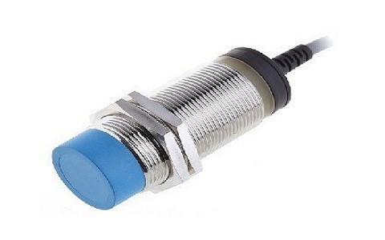

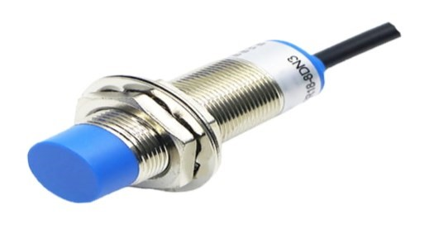**Capacitive Sensors:** Capacitive sensors are used to detect non-metallic objects based on their dielectric properties. These sensors measure the changes in capacitance when an object with a different dielectric constant, such as plastic or glass, comes near. Salah et al. (2021) explain that capacitive sensors can be fine-tuned to detect specific materials like plastic and glass, enabling more efficient waste segregation. The capacitive sensor's sensitivity can be adjusted to ensure accurate detection, especially when materials like plastic are difficult to distinguish from other materials.

**Ultrasonic Sensors:** Ultrasonic sensors are frequently used in waste sorting systems to measure the distance between the sensor and the material. These sensors emit sound waves and measure the time it takes for the wave to bounce back, determining the distance to the target object. Huang et al. (2019) highlight the importance of ultrasonic sensors in sorting systems, as they allow the system to detect the position of materials within the system, ensuring that they are properly positioned for sorting.

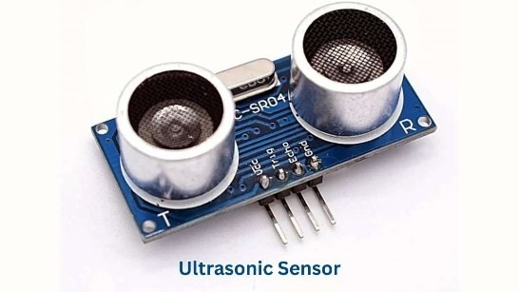

**Optical Sensors:** Optical sensors, such as cameras and spectrometers, are also gaining popularity in automated waste sorting. These sensors analyze the physical appearance and color of materials to identify specific types of waste, such as plastic bottles or paper. According to Cohen et al. (2020), optical sorting systems are particularly useful in sorting complex waste streams, including mixed plastics and paper products, based on visual cues.

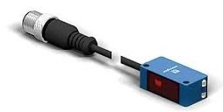

### 4. Robotics and Actuators in Waste Sorting

Robotic arms and actuators play a critical role in automating the physical process of moving waste materials from one area to another. The robotic system is typically paired with a series of sensors that detect materials and inform the robot of where to direct them.

Robotic Arms: Robotic arms are used in automated waste sorting systems to physically manipulate and sort materials based on sensor input. These arms are programmed to pick up materials and place them in designated bins. Zhao et al. (2018) discuss the use of robotic arms in recycling plants, where they are equipped with vision systems to identify and segregate different types of waste. The robots are capable of sorting objects at high speeds and with precision, greatly improving the throughput of recycling operations.

Servo Motors and Actuators: Servo motors and actuators are essential for controlling the movement of the sorting gates or bins. Li et al. (2021) present the use of servo motors to control sorting gates that direct materials to specific bins based on sensor readings. The precise control provided by servo motors ensures that materials are accurately sorted into their respective categories.

### 5. Machine Learning and Artificial Intelligence in Sorting Systems

Recent advancements in machine learning and artificial intelligence (AI) have made it possible to develop more sophisticated waste sorting systems that can learn and adapt to different materials and waste streams. AI algorithms are used to analyze sensor data and make decisions about how materials should be sorted.

Xie et al. (2020) propose an intelligent waste sorting system that uses machine learning algorithms to classify different waste materials. The system uses data from multiple sensors (including optical, capacitive, and ultrasonic) to train a model that can accurately identify a wide range of materials. By continuously learning from new data, the system becomes more efficient over time, improving its ability to sort even more complex waste streams.

Additionally, Wu et al. (2022) highlight the integration of deep learning with image recognition systems in waste sorting. Deep learning models, when trained on large datasets of images of waste materials, can classify objects with high accuracy. These systems are especially useful in sorting mixed materials where other sensor types may struggle, such as in the case of plastics and organics.

### 6. Challenges and Future Directions

While automated waste sorting systems have made significant progress, several challenges remain that need to be addressed for widespread adoption.

**Sensor Limitations:** Sensors such as capacitive and inductive types have their limitations, especially in detecting complex materials. Capacitive sensors may struggle to distinguish between similar materials with similar dielectric properties. Similarly, inductive sensors may fail to detect non-ferrous metals or objects that are too small to affect the electromagnetic field.

**System Integration:** Integrating various sensors, actuators, and robotic arms into a cohesive system remains a technical challenge. Ensuring that all components work seamlessly together requires careful calibration and synchronization.

**Cost and Scalability:** The cost of deploying automated waste sorting systems can be prohibitively high, especially for small-scale applications. Reducing the cost of sensors and actuators and improving the scalability of the system will be key to making these systems more accessible.

**Handling Complex Waste Streams:** Current systems are primarily designed to sort a few basic materials. However, the complexity of waste streams—especially in urban and industrial settings—requires the ability to sort a larger variety of materials, including mixed plastics, organic waste, and electronic waste (e-waste).

## 4. WORKING

The working of the Automatic Waste Sorting Machine involves several key steps, which are detailed below:

**Initialization:**

When the machine is powered on, the system initializes by setting the servo motors to their home positions. This ensures that all components are in a known state before starting the sorting process.

The sensors are calibrated during initialization to ensure accurate material detection.

**Material Detection:**

As waste enters the detection area, the inductive sensor detects metal objects by sensing changes in the magnetic field caused by the metal.

The capacitive sensor identifies plastic and glass objects by measuring the change in capacitance when the material approaches. The sensor is fine-tuned to distinguish between plastic and glass based on their dielectric properties.

The ultrasonic sensor continuously measures the distance of the object from the sensor. This helps the system determine whether the object is within the sorting range and ready to be moved.

**Sorting Process:**

Once the material is detected, the system processes the sensor readings and determines the type of material. Based on the material type, the corresponding servo motor is activated to move the waste to the appropriate bin.

If metal is detected, the pipe servo directs the material to the metal bin.

If plastic is detected, the pipe is moved to the plastic bin.

If glass is detected, the material is directed to the glass bin.

**Servo Control:**

The servo motors are controlled using PWM (Pulse Width Modulation) signals from the Arduino Uno. The servo motors move to specific angles based on the input from the sensors, ensuring that each type of waste is directed to its respective bin.

The system is designed to return the servo motors to their initial positions after each sorting cycle to ensure the system is ready for the next round of waste detection.

**End of Process:**

After the waste is sorted, the system waits for the next item to be detected. The process repeats for each piece of waste that enters the system.

## 5. METHODOLOGY

The development of the Automatic Waste Sorting Machine involved several stages, including system design, component selection, programming, and testing. Below is a detailed overview of the methodology followed:

**Design and Component Selection:**

The first step was to define the requirements and design the system. The machine was designed to use inductive sensors for metal detection, capacitive sensors for plastic and glass detection, and ultrasonic sensors to measure distance. The mechanical structure was designed to hold the sensors and motors in place while ensuring smooth operation.

Components like Arduino Uno, servo motors, sensors, and power supply were selected based on their suitability for the application and their compatibility with the Arduino platform.

**Mechanical Design:**

The frame of the machine was constructed using a combination of 3D printed parts and lasercut parts. The frame holds the sensors and servos in place and provides the necessary support for the sorting mechanism.

The V-gate and pipe mechanisms were designed to move the waste to the respective bins based on the sensor readings.

**Programming:**

The Arduino Uno was programmed to control the servo motors and process the sensor inputs. The code was written in the Arduino IDE and used standard libraries to interface with the sensors and motors.

The system was programmed to initialize the servos, detect materials, and sort them using a series of conditional statements based on sensor values. The system was also programmed to handle errors and perform initialization routines.

**Testing and Calibration:**

The system was tested with different types of waste materials to ensure that the sensors could accurately detect metal, plastic, and glass.

Calibration of the sensors was an important part of the process, as the sensitivity of the sensors needed to be adjusted to accurately differentiate between different materials.

The system was iteratively tested, and adjustments were made to the code and hardware to improve accuracy and efficiency.

**CHAPTER-2**

# SYSTEM OVERVIEW

The fig.1 shows block diagram which gives you the overview of the proposed system. The brief description given bellow.

**2.1**

**Block Diagram**

**a**

**m**

PLASTIC

/

GLASS

IDENTIFIER

METAL

SENSOR

ATMega328

Microcontroller

ULTRASONIC

SENSOR

SERVO

MOTOR

POWER

SUPPLY

DC

MOTOR

**2.2 FUNCTIONAL UNIT DESCRIPTION:**

In the figure 2.1 we shown the hardware requirements & Technical approach in the way to design the system. The system consists of mainly parts like Microcontroller (ATmega328), RFID technology, Sensor networks, which are described briefly below.

## 2.3 MICROCONTROLLER ATMEGA328

Arduino UNO is an open source prototyping platform based on ATmega328 microcontroller. It consists of 14 digital input/output (I/O) pins, six analogue inputs, a USB connection for programming the on-board microcontroller, a power jack, an ICSP header and a reset button.

It is operated with a 16MHz crystal oscillator and contains everything needed to support the microcontroller.

### 2.4 ULTRASONIC SENSOR

IR sensor is used to detect the level of the dust bin, The IR is line of sight distance sensor. The sensor circuit mainly consists of two blocks i.e. IR transmitter and IR receiver. The transmitter transmits the IR rays continuously and received by the receiver. When the beam is broken a high to low signal produced, that signal is fed to the microcontroller. These circuit are unaffected by sunlight and other artificial lights; range of this circuit is about 5 meters without any lenses. Range can be extended further by using lenses or reflector with sensors.

### 2.5 CAPACITIVE SENSOR

Capacitive sensors are devices that detect changes in capacitance (the ability to store an electrical charge) when a conductive object, such as a human finger, approaches or touches the sensor. These sensors typically consist of two conductive plates separated by an insulating material, forming a capacitor.

When an object (like a finger) comes near the sensor, it alters the electric field around the plates, changing the capacitance. This change is detected by the sensor’s electronics, which then trigger a response, such as turning on a device, sending a signal, or activating a function.

### 2.6 DC MOTOR

A DC motor is used to provide rotary motion in various electronic projects and applications. It consists of a rotor (or armature), stator, and brushes. When a voltage is applied to the motor, it creates a magnetic field that causes the rotor to spin. The direction of rotation depends on the polarity of the applied voltage. DC motors are widely used for driving wheels, fans, and other mechanical components in robotics, automation, and other motion-controlled systems. The speed of a DC motor can be adjusted by varying the voltage supplied to the motor, and its direction of rotation can be controlled by reversing the polarity of the voltage. In the context of the smart dustbin project, a DC motor may be used for opening or closing lids or activating mechanisms for waste segregation.

### 2.7 NPN METAL PROXIMITY SENSOR

An NPN metal proximity sensor is used to detect the presence of metal objects within a certain range without any physical contact. It operates based on the principle of eddy currents generated in metal objects when subjected to an alternating magnetic field. The sensor consists of an oscillator that generates the magnetic field and a receiver that detects the changes in the field caused by nearby metal. When a metal object enters the sensor’s detection range, the changes in the magnetic field are detected, and a signal is sent to the microcontroller. The NPN sensor typically produces a low signal when no metal is detected and switches to a high signal when metal is in the detection zone. These sensors are commonly used in industrial applications, robotic systems, and automated machines to detect metal parts or obstacles. In the waste segregation system, the metal proximity sensor helps in identifying metal waste for proper sorting.

### 2.8 SERVO MOTORS

A servo motor is a linear or rotary actuator that provides fast precision position control for closed-loop position control applications. Unlike large industrial motors, a servo motor is not used for continuous energy conversion.

Servo motors work on servo mechanism that uses position feedback to control the speed and final position of the motor. Internally, a servo motor combines a motor, feedback circuit, controller and other electronic circuit.

CHAPTER-3

## MICROCONTROLLER

### 3.1 Introduction

To make a complete microcomputer system only micro controller is not sufficient, it is necessary to add other peripherals such as read only memory (ROM), read / write memory (RAM), decoders, drivers, latches, number of input / output devices to make a complete microcomputer system. In addition, special purpose devices, such as interrupt controller, programmable timers, programmable I/O devices, DMA controllers, USART/UART, programmable keyboard/display drivers may be added to improve the capability, performance and flexibility of a microcomputer system. In addition battery backup and an elaborate power supply arrangement is essential. However the key feature of micro controller based computer system is that, it is possible to design a system with a great flexibility. It is possible to configure a system as large or as small system by adding or removing suitable peripherals. On the other hand, the micro controller incorporates all the features that are found in micro controller. However, it has added features to make a complete microcomputer system on its own. Therefore the micro controllers are sometimes called as single chip microcomputer. The micro controller has built-in rom, ram, parallel I/O, serial I/O, counters, interrupts and a clock oscillator circuit.

### SPECIAL FEATURES OF ATmega328 MICROCONTROLLER

High Performance, Low Power AVR® 8-Bit Microcontroller

#### • Advanced RISC Architecture

1. 131 Powerful Instructions
2. Most Single Clock Cycle Execution
3. 32 x 8 General Purpose Working Registers
4. Fully Static Operation
5. Up to 20 MIPS Throughput at 20 MHz
6. On-chip 2-cycle Multiplier

#### • High Endurance Non-volatile Memory Segments

1. 4/8/16/32K Bytes of In-System Self-Programmable Flash program memory

(ATmega48PA/88PA/168PA/328P)

1. 256/512/512/1K Bytes EEPROM (ATmega48PA/88PA/168PA/328P)
2. 512/1K/1K/2K Bytes Internal SRAM (ATmega48PA/88PA/168PA/328P)
3. Write/Erase Cycles: 10,000 Flash/100,000 EEPROM
4. Data retention: 20 years at 85°C/100 years at 25°C(1)
5. Optional Boot Code Section with Independent Lock Bits

* In-System Programming by On-chip Boot Program
* True Read-While-Write Operation

a. Programming Lock for Software Security

* **Peripheral Features** 
  + - 1. Two 8-bit Timer/Counters with Separate Presale and Compare Mode
      2. One 16-bit Timer/Counter with Separate Presale, Compare Mode, and Capture

Mode

* + - 1. Real Time Counter with Separate Oscillator
      2. Six PWM Channels
      3. 8-channel 10-bit ADC in TQFP and QFN/MLF package
* **Temperature Measurement** 
  + - 1. 6-channel 10-bit ADC in PDIP Package
      2. Programmable Serial USART
      3. Master/Slave SPI Serial Interface
      4. Byte-oriented 2-wire Serial Interface (Philips I2C compatible)
      5. Programmable Watchdog Timer with Separate On-chip Oscillator
      6. On-chip Analog Comparator
      7. Interrupt and Wake-up on Pin Change
* **Special Microcontroller Features** 
  + - 1. Power-on Reset and Programmable Brown-out Detection
      2. Internal Calibrated Oscillator
      3. External and Internal Interrupt Sources
      4. Six Sleep Modes: Idle, ADC Noise Reduction, Power-save, Power-down,

Standby, and Extended Standby

* **I/O and Packages** 
  + - 1. 23 Programmable I/O Lines
      2. 28-pin PDIP, 32-lead TQFP, 28-pad QFN/MLF and 32-pad QFN/MLF
* Operating Voltage: 1.8 - 5.5V for ATmega48PA/88PA/168PA/328P
* Temperature Range: -40°C to 85°C
* Speed Grade: 0 - 20 MHz @ 1.8 - 5.5V
* Low Power Consumption at 1 MHz, 1.8V, 25°C for ATmega48PA/88PA/168PA/328P:
  + - 1. Active Mode: 0.2 mA
      2. Power-down Mode: 0.1 μA
      3. Power-save Mode: 0.75 μA (Including 32 kHz RTC)

**3.3 Pin Description of ATmega328 Microcontroller:**

**Figure**

**2**

**:**

**Pin diagram of ATmega328 MC**

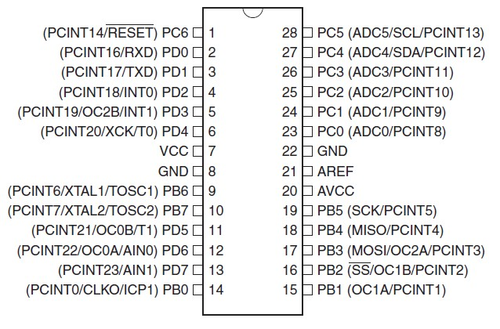

1.1 Pin Descriptions

* + 1. VCC: Digital supply voltage.
    2. GND: Ground.

##### 1.1.3 Port B (PB7:0) XTAL1/XTAL2/TOSC1/TOSC2

Port B is an 8-bit bi-directional I/O port with internal pull-up resistors (selected for each bit). The Port B output buffers have symmetrical drive characteristics with both high sink and source capability. As inputs, Port B pins that are externally pulled low will source current if the pull-up resistors are activated. The Port B pins are tri-stated when a reset condition becomes active, even if the clock is not running. Depending on the clock selection fuse settings, PB6 can be used as input to the inverting Oscillator amplifier and input to the internal clock operating circuit. Depending on the clock selection fuse settings, PB7 can be used as output from the inverting Oscillator amplifier.

##### 1.1.4 Port C (PC5:0)

Port C is a 7-bit bi-directional I/O port with internal pull-up resistors (selected for each bit). The PC5.0 output buffers have symmetrical drive characteristics with both high sink and source capability. As inputs, Port C pins that are externally pulled low will source current if the pull-up resistors are activated. The Port C pins are tri-stated when a reset condition becomes active, even if the clock is not running.

##### 1.1.5 PC6/RESET

If the RSTDISBL Fuse is programmed, PC6 is used as an I/O pin. Note that the electrical characteristics of PC6 differ from those of the other pins of Port C. If the RSTDISBL Fuse is un-programmed, PC6 is used as a Reset input. A low level on this pin for longer than the minimum pulse length will generate a Reset, even if the clock is not running. The minimum pulse length is given in Table 28-3 on page 308. Shorter pulses are not guaranteed to generate a Reset.

##### 1.1.6 Port D (PD7:0)

Port D is an 8-bit bi-directional I/O port with internal pull-up resistors (selected for each bit). The Port D output buffers have symmetrical drive characteristics with both high sink and source capability. As inputs, Port D pins that are externally pulled low will source current if the pull-up resistors are activated. The Port D pins are tri-stated when a reset condition becomes active, even if the clock is not running.

##### 1.1.7 AVCC

AVCC is the supply voltage pin for the A/D Converter, PC3:0, and ADC7:6. It should be externally connected to VCC, even if the ADC is not used. If the ADC is used, it should be connected to VCC through a low-pass filter. Note that PC6.4 use digital supply voltage, VCC.

**1.1.8 AREF:** AREF is the analog reference pin for the A/D Converter.

**1.1.9 ADC7:6:** (TQFP and QFN/MLF Package Only) In the TQFP and QFN/MLF package, ADC7:6 serve as analog inputs to the A/D converter. These pins are powered from the analog supply and serve as 10-bit ADC channels.

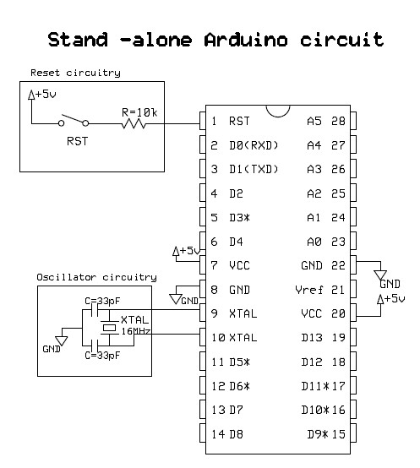

**Figure 3: Stand-alone ATmega328 microcontroller**

**What is Arduino?**

Arduino is an open-source prototyping platform based on easy-to-use hardware and software. Arduino boards are able to read inputs - light on a sensor, a finger on a button, turn it into an output - activating a motor, turning on an LED. We can tell your board what to do by sending a set of instructions to the microcontroller on the board.

## History

It was in the year 2005 that the first ever Arduino board was born in the classrooms of the **Interactive Design Institute in Ivrea, Italy**. Well, if you are not very familiar with the term, an Arduino is an Open Source microcontroller based development board that has opened the doors of electronics to a number of designers and creative engineers.

It was in the Interactive Design Institute that a hardware thesis was contributed for a wiring design by a Colombian student named **Hernando Barragan**.

## About Arduino

The new prototype board, the Arduino, created by **Massimo Banzi** and other founders, is a low cost microcontroller board that allows even a beginner to do great things in electronics. An Arduino can be connected to all kind of lights, motors, sensors and other devices; easy-to-learn programming language can be used to program how the new creation behaves. Using the Arduino, you can build an interactive display or a mobile robot or anything that you can imagine.

**David A. Mellis**, the lead software developer of Arduino, states that this little board has made it possible for people to do things they wouldn’t have done otherwise.

## Advantages

* ***Inexpensive:*** Pre-assembled Arduino modules cost less than Microcontroller
* ***Cross-platform:*** The Arduino Software (IDE) runs on Windows, Macintosh OSX, and Linux operating systems. Most microcontroller systems are limited to Windows.
* ***Simple, clear programming environment:*** The Arduino Software (IDE) is easy-to-use for beginners, yet flexible enough for advanced users to take advantage of as well.
* ***Open source and extensible software:*** Same tool can be used for C, C++, AVR Code developers.
* ***Open source and extensible hardware:***  Experienced circuit designers can make their own version of the module, extending it and improving it.

### ARDUINO UNO BOARD

The Uno is a microcontroller board based on the ATmega328P. It has 14 digital input/output pins (of which 6 can be used as PWM outputs), 6 analog inputs, a 16 MHz quartz crystal, a USB connection, a power jack, an ICSP header and a reset button. It contains everything needed to support the microcontroller; simply connect it to a computer with a USB cable or power it with a AC-to-DC adapter or battery to get started.. You can tinker with your UNO without worrying too much about doing something wrong, worst case scenario you can replace the chip for a few Rupees and start over again.

"Uno" means one in Italian and was chosen to mark the release of Arduino Software (IDE) 1.0. The Uno board and version 1.0 of Arduino Software (IDE) were the reference versions of Arduino, now evolved to newer releases. The Uno board is the first in a series of USB Arduino boards, and the reference model for the Arduino platform; for an extensive list of current, past or outdated boards see the Arduino index of boards.

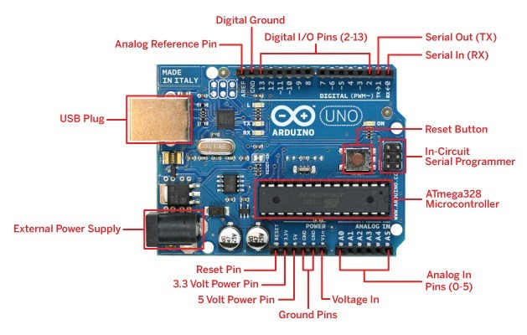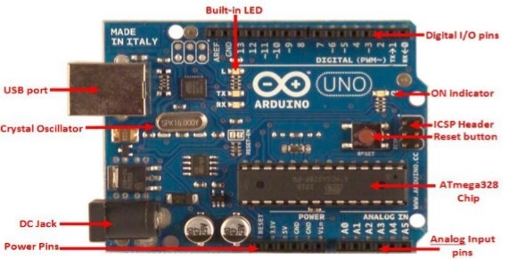

**Component Explanations:**

* ***Analog input Pins:*** Pins (A0-A5) that take-in analog values to be converted to be represented with a number range 0-1023 through an Analog to Digital Converter (ADC).
* ***ATmega328 chip:*** 8-bit microcontroller that processes the sketch you programmed.
* ***Built-in LED:*** In order to gain access or control of this pin, you have to change the configuration of pin 13 where it is connected to.
* ***Crystal Oscillator:*** clock that has a frequency of 16MHz
* ***DC Jack:***  where the power source (AC-to-DC adapter or battery) should be connected.

It is limited to input values between 6-20V but recommended to be around 7-12V.

* ***Digital I/O pins:*** Input and output pins (0-13) of which 6 of them (3, 5, 6, 9, 10 and 11) also provide PWM (Pulse Width Modulated) output by using the analogWrite() function. Pins (0 (RX) and 1 (TX)) are also used to transmit and receive serial data.
* **ICSP Header:** pins for “In-Circuit Serial Programming” which is another method of programming.
* ***ON indicator:*** LED that lights up when the board is connected to a power source.
* ***Power Pins:*** Pins that can be used to supply a circuit with values VIN (voltage from DC Jack), 3.3V and 5V.
* ***Reset Button:*** A button that is pressed whenever you need to restart the sketch programmed in the board.
* ***USB port:*** Allows the user to connect with a USB cable the board to a PC to upload sketches or provide a voltage supply to the board. This is also used for serial communication through the serial monitor from the Arduino software.

### ATmeg328 MICROCONTROLLER

**Arduino Pin-Map:**

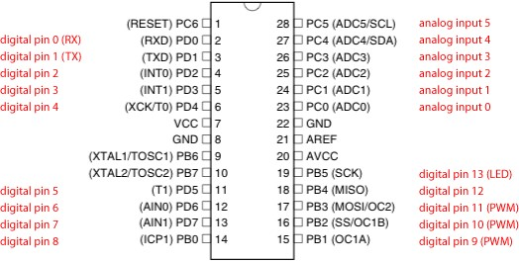

Technical Specifications

|  |  |
| --- | --- |
| Microcontroller | [ATmega328P](http://www.atmel.com/Images/doc8161.pdf) |
| Operating Voltage | 5V |
| Input Voltage (recommended) | 7-12V |
| Input Voltage (limit) | 6-20V |
| Digital I/O Pins | 14 (of which 6 provide PWM output) |
| PWM Digital I/O Pins | 6 |
| Analog Input Pins | 6 |
| DC Current per I/O Pin | 20 mA |
| DC Current for 3.3V Pin | 50 mA |
| Flash Memory | 32 KB (ATmega328P)  of which 0.5 KB used by bootloader |
| SRAM | 2 KB (ATmega328P) |
| EEPROM | 1 KB (ATmega328P) |
| Clock Speed | 16 MHz |
| Length | 68.6 mm |
| Width | 53.4 mm |
| Weight | 25 g |

CHAPTER-4

# SENSOR & COMPARATORS

Sensors are sophisticated devices that are frequently used to detect and respond to electrical or optical signals. A Sensor converts the physical parameter (for example: temperature, blood pressure, humidity, speed, etc.) into a signal which can be measured electrically.

## Criteria to choose a Sensor

There are certain features which have to be considered when we choose a sensor. They are as given below:

1. Accuracy
2. Environmental condition - usually has limits for temperature/ humidity
3. Range - Measurement limit of sensor
4. Calibration - Essential for most of the measuring devices as the readings changes with time
5. Resolution - Smallest increment detected by the sensor
6. Cost

Repeatability - The reading that varies is repeatedly measured under the same environment

## 4.2 IR sensor

### Level Sensing circuit (IR transceiver)

The sensor circuit mainly consists of two blocks i.e. IR transmitter and IR receiver. The transmitter transmits the IR rays continuously and received by the receiver. When the beam is broken a high to low signal produced, that signal is fed to the microcontroller. These circuit are unaffected by sunlight and other artificial lights, range of this circuit is about 5 meters without any lenses. Range can be extended further by using lenses or reflector with sensors.

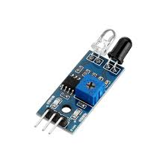

## 4.2 COMPARATOR CIRCUIT

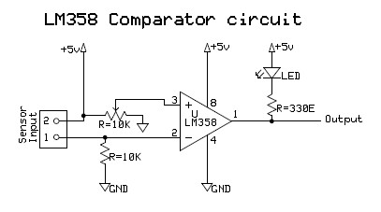

**Figure**

**4**

**:**

**Comparator circuit diagram**

The LM358 consist of two independent, high gain, internally frequency compensated operational amplifiers which were designed specifically to operate from a single power supply over a wide range of voltage. Operation from split power supplies is also possible and the low power supply current drain is independent of the magnitude of the power supply voltage. Application areas include transducer amplifier, DC gain blocks and all the conventional OPAMP circuits which now can be easily implemented in single power supply systems. Here we using LM358 as a comparator circuit.

CHAPTER-5

# COMMUNICATION

Communication is the activity of conveying information through the exchange of messages, or information. The system which is to displays the next station information. To establish the communication between the station and Train we using RF communication system.

## 5.1 Block diagram of Communication System

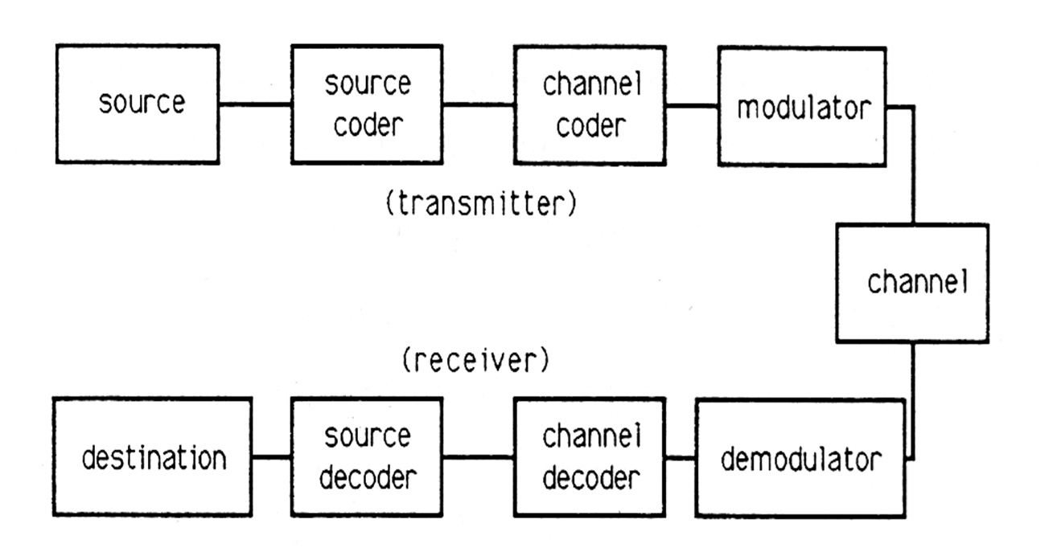

### Transmitter

Transmitter is the transmitting part in this block diagram. Using this system we can generate the messages which are to be sent through this system.

### Receiver

This is the Receiving part in block diagram of communication system. This can be said as the target to which the information needs to be delivered.

### Encoder

Encoder is the second element in the communication system. It performs the encoding of the given data, which means that this system converts the messages in the form of symbols for transmission purpose. In this system, sequences of characters are created in a special format for an effective transmission. This encoding system is used for security purpose.

### Decoder

Decoder is used to decode the encoded message and retrieve the actual message. Decoding must be done correctly. If this part is not performed well then the message which is received might not be correct.

*This encoding and decoding will be very help full in military and mobile communications.*

### Channel

This is the main block in the block diagram of communication system. Noisy channel is nothing but the medium through which the message is transmitted. Messages are conveyed through this channel. Different channels have different strengths and weaknesses. Each channel has its own frequency and different applications have different operating frequencies.

### Modulation and Demodulation

*Modulation* is a process, in which any one of the characteristics (Amplitude, Phase, and Frequency) of carrier wave is varied in accordance with the message signal.

Retrieving the original message signal from the Modulated signal is known as *Demodulation*.

CHAPTER-6

# HARDWARE IMPLIMANTATION

**6.1 Regulated Power Supply Unit Definition:**

A power supply (sometimes known as a regulated power supply unit or RPSU) is a device or system that supplies electrical or other types of energy to an output load or group of loads. The term is most commonly applied to electrical energy supplies, less often to mechanical ones, and rarely to others.

**6.1.1**

**Block diagram**

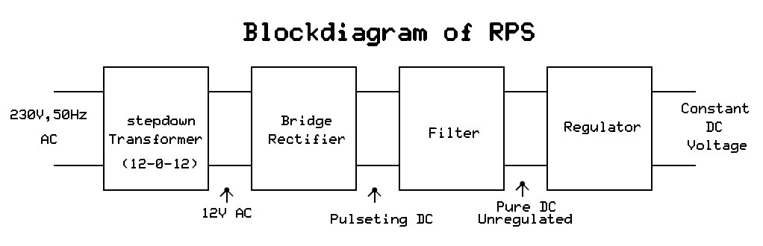

**Figure 5: Block diagram of Regulated Power supply Unit**

* The first section is the transformer. The transformer steps up or steps down the input line voltage and isolates the power supply from the power line.
* The rectifier section converts the alternating current input signal to a pulsating direct current. However, as you proceed in this chapter you will learn that pulsating dc is not desirable.
* For this reason a filter section is used to convert pulsating dc to a purer, more desirable form of dc voltage.
* 78xx chip family gives different output voltage as regulator. The last numbers in the chip code tells the output voltage.

## Brief summery

* Output Voltages: Gives out well regulated +5V output, output current capability of 100 ma
* Circuit protection: Built-in overheating protection shuts down output when regulator

IC gets too hot

* Circuit complexity: Very simple and easy to build
* Circuit performance: Very stable +5V output voltage, reliable operation
* Availability of components: Easy to get, uses only very common basic components
* Design testing: Based on datasheet example circuit, We used this circuit successfully as part of many electronics projects
* Applications: Part of electronics devices, small laboratory power supply
* Power supply voltage: Unregulated DC 8-18V power supply
* Power supply current: Needed output current + 5 ma
* Component costs: Few rupees for the electronics components + the input transformer cost.

1. **TRANSFORMER:**

A step-down type transformer is used to reduce the mains voltages to a suitable low voltage. It is a device, which transforms the 230 volts 50 Hz, A.C mains voltage, to required small voltages. Our design uses a full wave bridge rectifier with a center-tapped transformer, to obtain dual-tracking voltages i.e., to get +Ve and –Ve voltages with respect to ground. A transformer with a power output rated at at-lest 15 VA should be used. If the transformer is rated by output RMS-current then the value should be divided by 1.2 to get the current, which can be supplied. For example, in this case a 1A RMS can deliver 1/ (1.2) or 830 ma.

1. **RECTIFIER:**

The rectifier is built using power diodes. For the maximum efficiency and low ripple, a full wave or a bridge configuration is always preferred. The diodes chosen should have a peak inverse voltage of at-least 200 volts. For safety, the diode voltage rating should be at-least 3 to 4 times that of the transformer secondary voltage. The current rating of the diodes should be twice the maximum load current.

**3)FILTER:**

The purpose of the filter is to eliminate the ripple from the rectified D.C voltage. Capacitor filter has been used in this design from the viewpoint of compactness and economy. Though very simple, capacitor filters provide excellent filtering action. The residual amount of ripple is determined by the value of the filter capacitor: the larger the value the smaller is the ripple. The 2200 uf is a suitable value for most of the requirements. The other consideration in choosing the correct capacitor is its voltage rating. The working voltage of the capacitor has to be greater than the peak output voltage of the rectifier. For example, for an 18 V supply, the peak output voltage is 1.4 X 18V =25V. So a capacitor with working voltage greater than 25V is required.

Filter design equations:

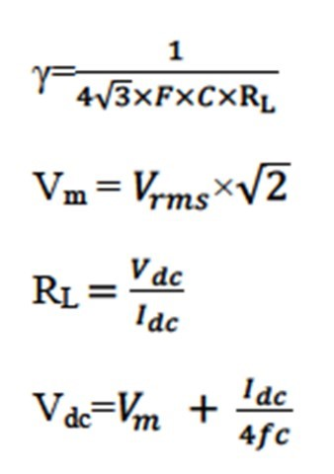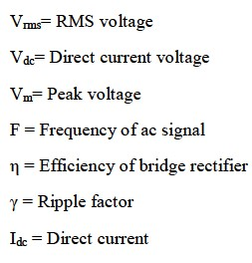

1. **REGULATOR:**

There are many designs possible for a voltage regulator. Many conventional regulators are best suited for constant voltage supply, but the number of discrete components and circuit design makes it not much an attractive choice, especially for the dual tracking type power supplies.

Fixed voltage regulator, which are very much efficient, compact and economic are available as three terminal regulator chips. These chips needs no external components and provide up to 1A current and operate well, even under worst situations of line, load and temperature. The 78XX series are the positive fixed voltage regulators, with its output voltage specified by the last two digits. Similarly the 79XX series are the negative fixed voltage regulators.

### 6.3 PCB Layout design & Fabrication

A Printed Circuit Board doesn’t just connect electrical components using etched copper pathways, but also provides mechanical strength to it. Printed Circuit Boards, or more appropriately, Printed Wiring Boards are found in almost all of the commercial products as a packaging medium as building blocks. PCBs are a composite of organic and/or inorganic dielectric materials with many layers with wiring interconnects and also house components like inductors and capacitors. There isn’t any standard printing board as such and each board is unique, often a function of the product itself. There are industry standards for almost every aspect of PCB design, controlled by IPC, for example the IPC-2221, ‘Generic Standard on Printed Board Design’.

## History

PCBs have evolved from the electrical connection systems developed in the 1850s. The first patents on Printed Wires were issued in 1903. Albert Hanson explained a layered structure of foil conductors laminated to insulation boards. Arthur Berry patented a ‘Print-and-Etch’ method in 1913 and Max Schoop patented Flame Spraying metal onto a board via a mask. Thomas Edison had experimented with chemicals for plating conductors on linen paper way back in 1904, but the method of electroplating circuit patterns was finally successfully patented to Charles Durcase in the year 1927. Charles Ducas had earlier patented a technique of creating electrical paths directly using stencils and electrically conductive ink in 1925.

World War II saw the invention of circuit boards that could withstand gunshots. But, the credit of developing the first PCB is given to Paul Eisler in 1943, for developing a method of etching conductive circuits on copper foil bonded to a non-conductive base reinforced by glass. The method remained dormant until late 50s when the transistors were introduced for commercial use. The presence of wire leads on electronic components led to the development of ‘Through Hole’ technology where holes were drilled into the PCB and the components soldered on to the board at those points. It was patented by a U.S. firm Hazeltyne in 1961. However, this process being slightly expensive and wasteful as the extra wire is cut off and not used much. Nowadays, ‘surface mount’ technology is gaining impetus as the demand for smaller, high density circuits is increasing.

## Design flow

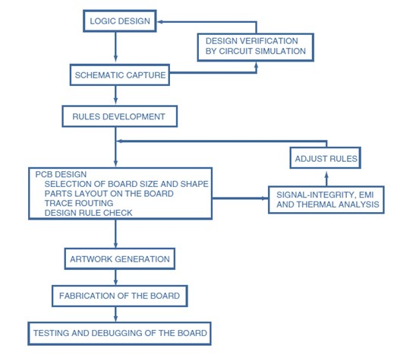

Throughout the manufacturing process of a PCB, visual and electrical inspection is carried out to locate any flaws that might have crept in due to process automation like ‘Tombstone effect’ when the solder is heated too quickly and one end of the component lifts up from the board failing to make contact, or excess flow of solder or bridging. Even after the manufacturing process, the boards are tested for the output levels under varying conditions of environment, stress and strain.

Back in the olden days, when PCBs had just been introduced, military was the chief consumer. But as the technology progressed and as the need grew, more and more interest was diverted towards better PCBs and as of today, they serve as the base for a multitude of components, gadgets and devices ranging from ever innovating computers and cell phones to basic equipment’s like television, radio and toys for children. Soon there are going to be more mobile phones than there are people in this world and the trend will continue to rise. This might be a convenience to the users, but isn’t without hazards either, combating which offers great scope for people from diverse fields.

## PCB Manufacturing

Artwork is generated by sending the design files in a particular format to plotters and transparencies for PCB manufacturing are produced. After this the manufacturing of the PCB commences. There are mainly five standard technologies used in PCB manufacturing:

### 1. Machining

This includes drilling, punching holes and routing on a PCB with standard existent machinery and also new technologies like laser and water jet cutting. The strength of the board needs to be taken into account while machining for accurate hole diameters. Small holes make this method costly and less reliable due to reduced aspect ratio and also making plating difficult.

### 2. Imaging

This step transfers the circuit artwork onto individual layers. Single sided or double sided PCBs may use simple Screen Printing technology for creating the patterns on a print-and-etch basis. But this has a limitation on the minimum line width achievable. For fine line boards and multilayer boards, Photo imaging is used which may be applied by flood screen printing, dip coating, Electrophoresis, roller laminating or liquid roller coating. Recently, direct laser imaging and liquid crystal light valve imaging have also been employed for the same.

### 3. Laminating

This process is mainly used for manufacturing multilayer boards, or the base laminates of single/double sided boards. B-stage epoxy resin impregnated glass sheets are pressed between layers using hydraulic press to bond the layers together. The pressing may be cold, hot, vacuum assisted or vacuum autoclave nominated offering close control on dielectrics and thickness.

### 4. Plating

It is basically the metallization process which may be brought about either by wet chemical processes like electro less plating and electrolytic plating or dry processes like sputtering and CVD. While electro less plating offers high aspect ratios and no external current thus forming the core of additive technology, electrolytic plating is the preferred method for bulk metallization. Recent developments like the plasma processing offer greater efficiency and quality while taxing less on the environment.

### 5. Etching

The removal of unwanted metal and dielectric from the board takes place by either dry or wet processes. The uniformity of etching is the prime concern in this stage and to extend the fine line etching capabilities, new anisotropic etching solutions are being developed.

## 6.3 Miscellanies

### 6.3.1 LCD (16X2) display

LCD (Liquid Crystal Display) screen is an electronic display module and find a wide range of applications. A 16x2 LCD display is very basic module and is very commonly used in various devices and circuits. These modules are preferred over seven segments and other multi segment LEDs. The reasons being: LCDs are economical; easily programmable; have no limitation of displaying special & even custom characters (unlike in seven segments), animations and so on. A 16x2 LCD means it can display 16 characters per line and there are 2 such lines. In this LCD each character is displayed in 5x7 pixel matrix. This LCD has two registers, namely, Command and Data.

The command register stores the command instructions given to the LCD. A command is an instruction given to LCD to do a predefined task like initializing it, clearing its screen, setting the cursor position, controlling display etc. The data register stores the data to be displayed on the LCD. The data is the ASCII value of the character to be displayed on the LCD. Click to learn more about internal structure of a LCD.

**Pin Diagram:**

**FIG 6.5 PIN CONFIGURATION OF 2X16LCD**

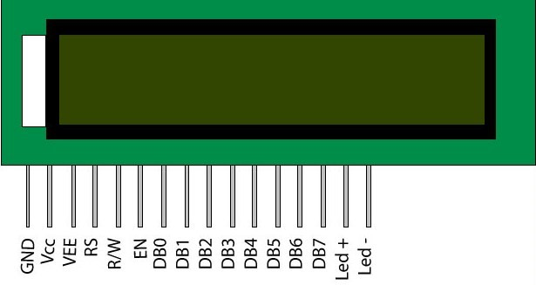

**Pin Description:**

|  |  |  |
| --- | --- | --- |
| **Pin No** | **Function** | **Name** |
| 1 | Ground (0V) | Ground |
| 2 | Supply voltage; 5V (4.7V – 5.3V) | Vcc |
| 3 | Contrast adjustment; through a variable resistor | VEE |
| 4 | Selects command register when low; and data register when high | Register Select |
| 5 | Low to write to the register; High to read from the register | Read/write |
| 6 | Sends data to data pins when a high to low pulse is given | Enable |
| 7 | 8-bit data pins | DB0 |
| 8 | DB1 |
| 9 | DB2 |
| 10 | DB3 |
| 11 | DB4 |
| 12 | DB5 |
| 13 | DB6 |
| 14 | DB7 |
| 15 | Backlight VCC (5V) | Led+ |
| 16 | Backlight Ground (0V) | Led- |

**TABLE 2. PIN DISCRIPTION OF 2X16LCD**

#### 6.4 Servo Motor

**What is a Servo Motor?**

A **servo motor** is an electrical device which can push or rotate an object with great precision. If you want to rotate and object at some specific angles or distance, then you use servo motor. It is just made up of simple motor which run through **servo mechanism**. If motor is used is DC powered then it is called DC servo motor, and if it is AC powered motor then it is called AC servo motor. We can get a very high torque servo motor in a small and light weight package. Doe to these features they are being used in many applications like toy car, RC helicopters and planes, Robotics, Machine .

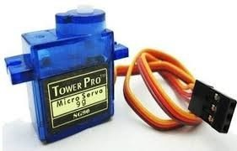

Servo motors are rated in kg/cm (kilogram per centimeter) most hobby servo motors are rated at 3kg/cm or 6kg/cm or 12kg/cm. This kg/cm tells you how much weight your servo motor can lift at a particular distance. For example: A 6kg/cm Servo motor should be able to lift 6kg if the load is suspended 1cm away from the motors shaft, the greater the distance the lesser the weight carrying capacity.

The position of a servo motor is decided by electrical pulse and its circuitry is placed beside the motor.

#### Servo Mechanism

It consists of three parts:

1. Controlled device
2. Output sensor
3. Feedback system
4. It is a closed loop system where it uses positive feedback system to control motion and final position of the shaft. Here the device is controlled by a feedback signal generated by comparing output signal and reference input signal.

Here reference input signal is compared to reference output signal and the third signal is produces by feedback system. And this third signal acts as input signal to control device. This signal is present as long as feedback signal is generated or there is difference between reference input signal and reference output signal. So the main task of servomechanism is to maintain output of a system at desired value at presence of noises.

#### Working principle of Servo Motors

A servo consists of a Motor (DC or AC), a potentiometer, gear assembly and a controlling circuit. First of all we use gear assembly to reduce RPM and to increase torque of motor. Say at initial position of servo motor shaft, the position of the potentiometer knob is such that there is no electrical signal generated at the output port of the potentiometer. Now an electrical signal is given to another input terminal of the error detector amplifier. Now difference between these two signals, one comes from potentiometer and another comes from other source, will be processed in feedback mechanism and output will be provided in term of error signal. This error signal acts as the input for motor and motor starts rotating. Now motor shaft is connected with potentiometer and as motor rotates so the potentiometer and it will generate a signal. So as the potentiometer’s angular position changes, its output feedback signal changes. After sometime the position of potentiometer reaches at a position that the output of potentiometer is same as external signal provided. At this condition, there will be no output signal from the amplifier to the motor input as there is no difference between external applied signal and the signal generated at potentiometer, and in this situation motor stops rotating.

**Controlling Servo Motor:**

All motors have three wires coming out of them. Out of which two will be used for Supply (positive and negative) and one will be used for the signal that is to be sent from the MCU.

Servo motor is controlled by PWM (Pulse with Modulation) which is provided by the control wires. There is a minimum pulse, a maximum pulse and a repetition rate. Servo motor can turn 90 degree from either direction form its neutral position. The servo motor expects to see a pulse every 20 milliseconds (ms) and the length of the pulse will determine how far the motor turns. For example, a 1.5ms pulse will make the motor turn to the 90° position, such as if pulse is shorter than 1.5ms shaft moves to 0° and if it is longer than 1.5ms than it will turn the servo to 180°.

Servo motor works on **PWM (Pulse width modulation)** principle, means its angle of rotation is controlled by the duration of applied pulse to its Control PIN. Basically servo motor is made up of **DC motor which is controlled by a variable resistor (potentiometer) and some gears**. H igh speed force of DC motor is converted into torque by Gears. We know that WORK= FORCE X DISTANCE, in DC motor Force is less and distance (speed) is high and in Servo, force is High and distance is less. Potentiometer is connected to the output shaft of the Servo, to calculate the angle and stop the DC motor on required angle.

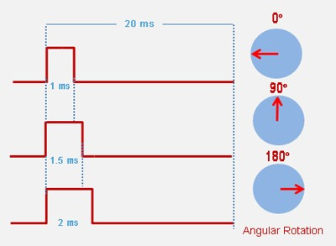

Servo motor can be

rotated from 0 to 180 degree, but it can go up to 210 degree, depending on the manufacturing. This degree of rotation can be controlled by applying the **Electrical Pulse** of proper width, to its Control pin. Servo checks the pulse in every 20 milliseconds. Pulse of 1 ms (1 millisecond) width can rotate servo to 0 degree, 1.5ms can rotate to 90 degree (neutral position) and 2 ms pulse can rotate it to 180 degree.

All servo motors work directly with your +5V supply rails but we have to be careful on the amount of current the motor would consume, if you are planning to use more than two servo motors a proper servo shield should be designed.

CHAPTER-7

# SOFTWARE DEVELOPMENT

## SOFTWARE INSTALLATION

### Installing ARDUINO IDE

To install the Arduino IDE for Windows, follow these instructions:

1. Download .exe file from website: <http://arduino.cc/en/Main/Software/>
2. Once the download is complete, double-click the file, and extract it. (Usually the file is downloaded in .zip format)
3. The extracted “Arduino” named folder is to be copy and paste it into C-Drive, and

Open the folder, if you wish create the shortcut of Arduino.exe file on your desktop.

### Installing DRIVERS

The next task is to install the drivers for your Arduino board’s USB interface.

1. Connect your Arduino to your PC with the USB cable. After a few moments an error message will be displayed, which will say something like “Device driver software not successfully installed.” Just close that dialog or balloon.
2. Navigate to the Windows Control Panel. Open the Device Manager and scroll down until you see the ports or Arduino,
3. Right-click *Arduino Uno* under Other Devices and select Update Driver Software.

Then, select browse option and update the drivers.

### Taking a look Around the IDE

The IDE is divided into three main areas: the command area, the text area, and the message window area.

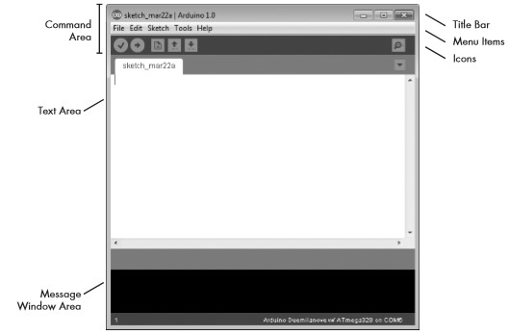

### The Command Area

The command area includes the title bar, menu items, and icons. The title bar displays the sketch’s filename. Below this is a series of menu items (File, Edit, Sketch, Tools, and Help) and icons.

***The Icons***

Below the menu toolbar are six icons. Mouse over each icon to display its name. The icons, from left to right, are as follows:

1. **Verify:** Click this to check that the Arduino sketch is valid and doesn’t contain any programming mistakes.
2. **Upload:** Click this to verify and then upload your sketch to the Arduino board.
3. **New:** Click this to open a new blank sketch in a new window.
4. **Open:** Click this to open a saved sketch. Save Click this to save the open sketch.
5. **Serial Monitor:** Click this to open a new window for use in sending and receiving data between your Arduino and the IDE.

**The Text Area**

The actual code is written in this block.

### The Message Window Area

The message window area is shown at the bottom side. Messages from the IDE appear in the black area. The messages you see will vary and will include messages about verifying sketches, status updates, and so on.

**CHALLENGES FACED:**

Every project on its own has its difficulties and challenges, for our project challenges are listed below:

**Rotating the Pipe:** Designing a mechanism, while bettering of the project done last year was a challenge. We wanted to have something that can be implemented in real life (like having a centralized garbage system in a Building). Countering the problem of the last year project we focused on not moving the Garbage can and so we went for a design which included a Pipe which rotates in 3 direction of fixed garbage can.

**Designing a Gate:** Designing a gate where the sensor detects the type of waste and directs it to the pipe, while the pipe rotates in the meantime to the respective garbage can was very tricky. We had several ideas from having an Objection plate while the garbage is held on the plate for detection and having a tilting bucket etc. Finally, we went for an idea of V-gate in order to avoid the movement of sensors and have less mechanical moving parts.

**Using bearings:** The original Idea involved using bearing both for V-gate shaft and Pipe support. As seen we used an 8 mm Radial bearing for Gate shaft on the either side. Also the rotating pipe shaft was to be supported by a thrust bearing, eventually we opted out of this idea as the wooden frame constructed for the Pipe was more than sufficient to support it. This saved a lot of time and prevented further any future mechanical complications in

the project.

**Using only one power supply:** It was a challenge to restrict our selves in using only one power supply and having least electronic components as possible. Therefore, in our design phase, we have considered all the possible ways to use only one power supply efficiently; and we opted for the scheme that is represented in the electronics chapter.

**Accuracy of sensors:** Sensors are not always accurate, having limitation in their distance of measurement. This affects its accuracy in detection (particularly when the object is small). We intended to modify the gate design by adding a printed part but it effected the performance of the sensor and so for future implications of the system for better detection, shielded sensors can be used.

**Position of Sensors:** There are many factors that came in to the picture while deciding the position and location of our sensors. We considered making a fixed structure for the sensors because we did not want the sensors to be attached to the gate. Also, the distance between the two sensors had to be considered so that the sensors do not influence each other. This has been done by considering the recommended distance in the datasheet and also by some trial and error we found the optimal locations to place our sensors.

**Initialization of the system:** In the start-up of the system, we wanted everything to go to the prescribed zero position. However, servos were moving without a command given to them (fast and not as commanded). We "fixed" this by considering the actual position of the motors on the system startup. Furthermore, one can consider here other ways of solving this issue, for instance, using different servos, other software solutions like using EEPROM; or hardware solutions.

**Tuning and adjusting different parameters of the system:** Tuning and adjusting different parameters of the system, and making everything work together was rather challenging. We opted for values that are optimal, however, the system response can be increased by changing these parameters (ex. speed of servos, the delays added into the code, etc.). Also, we observed that it will detect more efficiently metals if we only consider the data from the inductive sensor, this can be seen in the codes given in the programming section.

CHAPTER-8

## CONCLUSION & FUTURE WORK

In conclusion, the automated waste sorting machine represents a significant advancement in the management and recycling of waste. By utilizing cutting-edge technology, such as sensors, AI, and robotics, it can efficiently sort waste materials with greater accuracy and speed compared to traditional manual methods. This not only reduces the workload and cost of waste management but also contributes to environmental sustainability by ensuring that recyclable materials are properly segregated. The system's potential for scalability, adaptability, and integration with existing waste management infrastructure makes it a valuable tool for cities and industries aiming to reduce their carbon footprint and improve recycling rates. With continued innovation and investment, automated waste sorting could play a crucial role in the global effort toward waste reduction and resource conservation.

**CODE**

#include <Wire.h>

#include <LiquidCrystal_I2C.h>

#include <Servo.h>

// Define pins for sensors

#define metalSensorPin A0 // Analog pin for NPN metal proximity sensor

#define ultrasonicTrigPin 3 // Ultrasonic sensor trigger pin

#define ultrasonicEchoPin 4 // Ultrasonic sensor echo pin

#define irSensorPin 5 // IR sensor for glass detection

#define dcMotorUpDownPin1 6 // DC motor up movement

#define dcMotorUpDownPin2 7 // DC motor down movement

#define servoPin 9 // Servo motor pin

Servo myServo; // Servo motor object

// Define the distance threshold for plastic detection (in cm)

#define plasticThreshold 10

// Define analog threshold for metal detection (adjust based on your sensor output)

#define metalThreshold 100

// Initialize LCD (I2C address 0x27, 16 columns, 2 rows)

LiquidCrystal_I2C lcd(0x27, 16, 2);

void setup() {

// Initialize sensors

pinMode(ultrasonicTrigPin, OUTPUT);

pinMode(ultrasonicEchoPin, INPUT);

pinMode(irSensorPin, INPUT);

// Initialize DC motor pins

pinMode(dcMotorUpDownPin1, OUTPUT);

pinMode(dcMotorUpDownPin2, OUTPUT);

// Initialize the servo motor

myServo.attach(servoPin);

myServo.write(0); // Initial servo position

// Initialize the LCD

lcd.init(); // Set up the LCD's number of columns and rows

lcd.backlight();

lcd.clear();

lcd.setCursor(0, 0);

lcd.print(" WEL-COME");

lcd.setCursor(0, 1);

lcd.print("PDA ENG COLLEGE");

delay(2000);

Serial.begin(9600); // Start serial communication for debugging

}

void loop() {

lcd.clear();

lcd.setCursor(0, 0);

lcd.print("AUTOMATIC WASTE");

lcd.setCursor(0, 1);

lcd.print("SORTING MACHINE");

delay(2000);

int metalSensorValue = analogRead(metalSensorPin);

// Read the ultrasonic sensor for plastic detection

long duration, distance;

digitalWrite(ultrasonicTrigPin, LOW);

delayMicroseconds(2);

digitalWrite(ultrasonicTrigPin, HIGH);

delayMicroseconds(10);

digitalWrite(ultrasonicTrigPin, LOW);

duration = pulseIn(ultrasonicEchoPin, HIGH);

distance = (duration / 2) / 29.1; // Convert time to distance in cm

// Read the IR sensor for glass detection

int glassDetected = digitalRead(irSensorPin);

// Clear the LCD and update it with the detected material type

lcd.clear();

lcd.setCursor(0, 0);

// Check for metal

if (metalSensorValue < metalThreshold) {

lcd.print("Metal detected!");

Serial.println("Metal detected!");

operateMotorAndServo("metal");

}

// Check for plastic

else if (distance < plasticThreshold) {

lcd.print("Plastic detected!");

Serial.println("Plastic detected!");

operateMotorAndServo("plastic");

}

// Check for glass

else if (glassDetected == LOW) {

lcd.print("Glass detected!");

Serial.println("Glass detected!");

operateMotorAndServo("glass");

}

delay(500); // Delay to avoid excessive readings

}

void operateMotorAndServo(String type) {

// Rotate servo to drop the detected material based on the type

if (type == "metal") {

myServo.write(90); // Rotate to drop metal (you can adjust the angle)

} else if (type == "plastic") {

myServo.write(180); // Rotate to drop plastic

} else if (type == "glass") {

myServo.write(0); // Rotate to drop glass

}

delay(1000); // Wait for servo to finish movement

// Move the DC motor up and down after the servo has moved

digitalWrite(dcMotorUpDownPin1, LOW); // Move up

digitalWrite(dcMotorUpDownPin2, HIGH);

delay(2000); // Move for 2 seconds

digitalWrite(dcMotorUpDownPin1, HIGH); // Move down

digitalWrite(dcMotorUpDownPin2, LOW);

delay(2000); // Move for 2 seconds

digitalWrite(dcMotorUpDownPin1, LOW); // Stop motor

digitalWrite(dcMotorUpDownPin2, LOW);

// Reset the servo to initial position (0 degrees) after motor movement

myServo.write(0);

delay(500); // Wait a little to let the servo fully move to 0 position

}

**References**

1. "Waste Management: Principles and Practice" by J. M. P. De Silva pg.: 45-78 (Covers waste sorting technologies and practices)
2. "Recycling and Waste Management: A Global Perspective" by David A. W. Smith pg.: 102-130 (Discusses automated recycling systems and their efficiencies)
3. "Handbook of Recycling: State-of-the-art for Practitioners, Analysts, and Scientists" by Ernst Worrell and Markus Reuter pg.: 215-250 (Focuses on recycling technologies and automated sorting)
4. "Waste Management: A Reference Handbook" by David E. Newton pg.: 89-115 (Explores various waste management techniques including automation)
5. "Sustainable Waste Management: A Systems Approach" by Paul T. Williams pg.: 150-175 (Details on systems thinking in waste management and sorting)
6. "Automated Waste Sorting: A Review of Current Technologies" by Garcia, M., & Lopez, R., Journal of Environmental Engineering Vol. 146, No. 3, 2020 pg.: 1-15 (Comprehensive review of automated sorting technologies)
7. "The Role of Automation in Waste Management: A Review" by Thompson, J., & Patel, S., Waste Management Journal Vol. 95, 2020 pg.: 123-135 (Discusses the impact of automation on waste management systems)
8. "Sensor Technologies for Waste Sorting: A Review" by Patel, R., & Kumar, S., Sensors and Actuators A: Physical Vol. 310, 2020 pg.: 1-12 (Focuses on various sensor technologies used in waste sorting)
9. "Robotic Waste Sorting: Current Trends and Future Directions" by Lee, H., & Kim, J., Robotics and Autonomous Systems, Vol. 134, 2021, pg.: 45-60 (Explores advancements in robotic sorting systems)
10. "Innovations in Waste Sorting Technologies" by United Nations Environment Programme (UNEP) in 2021 pg.: 10-30 (Overview of innovative technologies in waste sorting)
11. A Review of Automated Waste Sorting Technologies" by Smith, J., & Jones, A. (2021). Journal of Environmental Management.
12. Advancements in Waste Sorting Technologies: A Comprehensive Review" by Kumar, R., & Singh, P. (2020). Waste Management Journal.
13. Advanced Sensor Applications in Waste Management Systems" by M. J. Schutet al.
14. Sustainable Waste Management: A Systems Approach" by Paul T. Williams
15. Sensor Technologies for Waste Sorting: A Review" by Patel, R., & Kumar, S. (2020). Sensors and Actuators A: Physical.
16. Sensors and Transducers" by Ian Sinclair, which covers sensor technologies applicable to waste sorting.
17. Sensors and Actuators: Engineering System Instrumentation" by Clarence de Silva.